### Unlocking Insights into the Global Air Transportation Network with Tableau

**Introduction:**

This Global Air Transportation Network dataset is a comprehensive collection of information on airports, airlines and their routes. It contains information such as names, cities, countries, codes (IATA and ICAO) longitudes, latitudes and altitudes of airports across the world with detailed time zone and daylight saving time data.

Additionally, this includes information about airlines including their IDs, name aliases, IATA and ICAO codes, call signs country of origin and active/inactive status. Similarly, it also covers route details such as airline sources to destination airports along with essential details like codeshare stakeholder if any stops required during this journey along with the type of aircraft being used for that particular journey. This dataset has been compiled through meticulous labor by researchers all over the world to give you a comprehensive detail into air transportation networks from around the globe.

**Objective:**

The business requirement of the Global Air Transportation Network- Airports, Airlines, and Routes dataset is to provide stakeholders in the aviation industry with accurate, up-to-date information on the worldwide air transportation network. The dataset is intended to help stakeholders make informed decisions related to business growth, investment, capacity planning, and infrastructure development. Using data analytics and visualization tools like Tableau, the dataset can be analyzed to identify trends and patterns in the air transportation network, providing valuable insights into the state of the industry. This information can be used to optimize routes, improve operational efficiency, and enhance customer experience.

Ultimately, the business requirement of the dataset is to enable stakeholders in the aviation industry to gain a competitive advantage by making data-driven decisions. By providing a comprehensive collection of data related to the air transportation network, the dataset can help stakeholders stay ahead of the curve in a dynamic and rapidly changing industry.

**Conclusion & Future Scope**

From a business perspective, the dataset can have a significant impact on the aviation industry. By enabling stakeholders to make data-driven decisions, the dataset can help airlines, airport authorities, tourism boards, and government agencies to identify new business opportunities, optimize capacity planning, and streamline operations. This can lead to increased profitability and competitiveness, as well as improved customer experience. Moreover, the dataset can be used by investors to identify promising sectors and geographic areas for investment in the aviation industry.

**Screenshot of Brainstorming Map:**

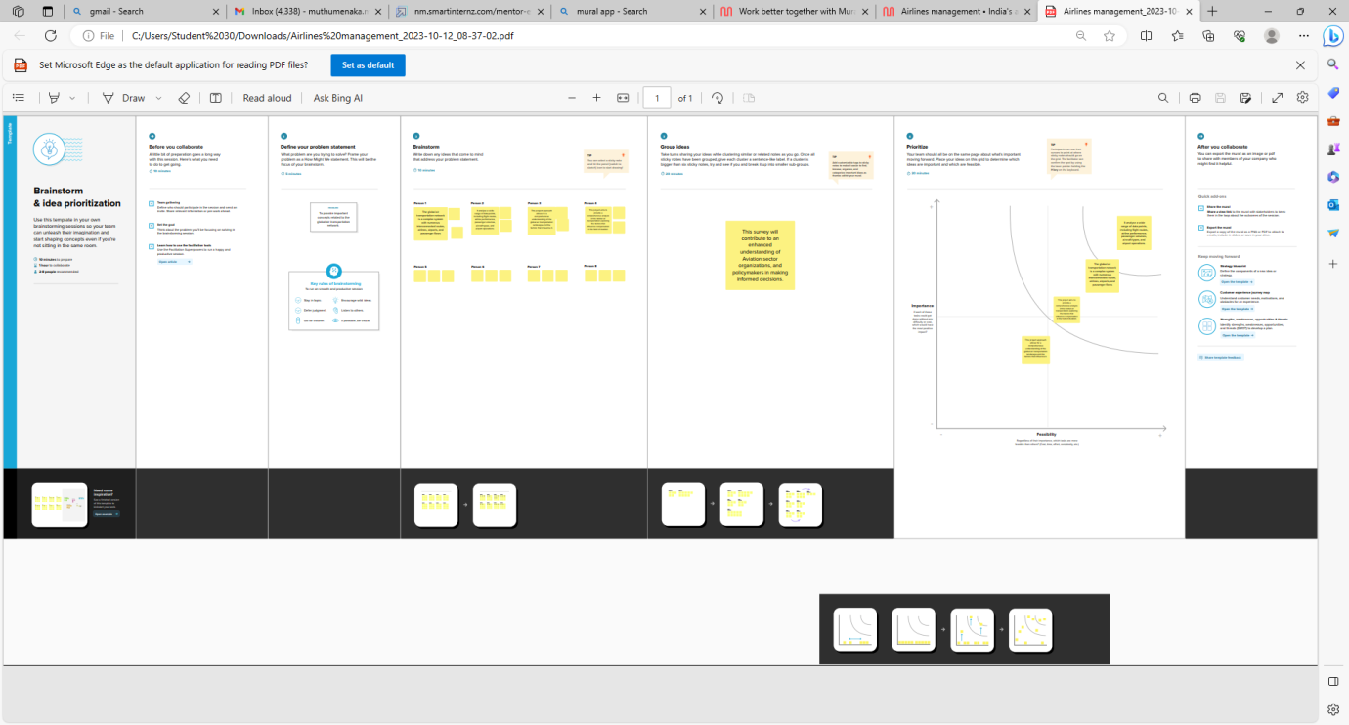

**Screenshot of Empathy Map:**

